#### SFO Branding and Color Palettes ☑

SFO’s color palette features modern, bold colors that reflect the airport’s brand personality. This palette should be used for any presentation documents prepared for a project. This can include architectural area plans, font color or line work, etc. These palettes are built into the SFO Revit Template, found in Color Schemes.

Use the following color specifications for the entire SFO color palette. Do not modify the colors and avoid approximating and visually matching the colors.

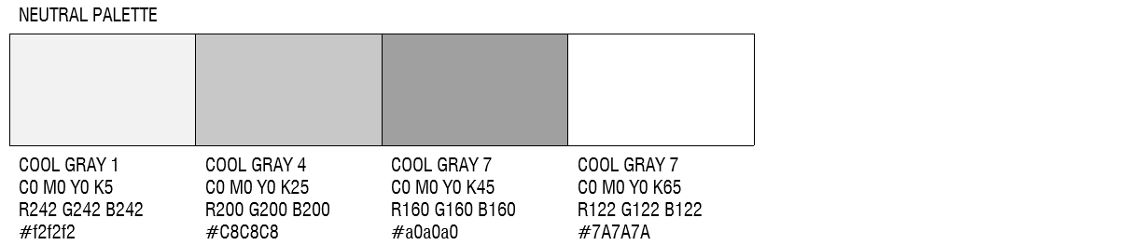

Figure 5.2‑4 Neutral Palette

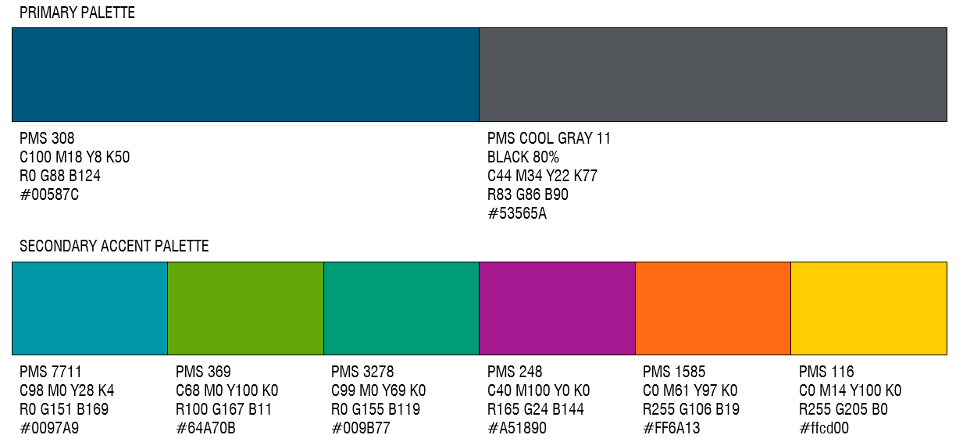

Figure 5.2‑5 Primary Palette

The neutral color palette was selected to complement the primary and secondary palettes.